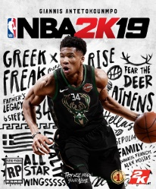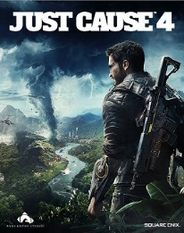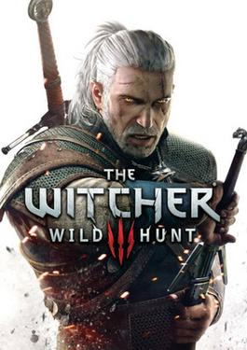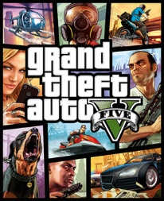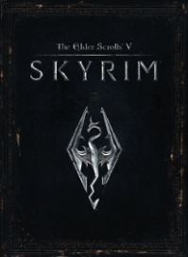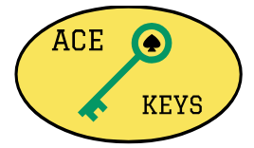

News

Anthem: BioWare's Big Gamble

With Anthem's impending release on PC, PS4, and Xbox One, we explore the pitfalls of the "games-as-service" genre, and the risks of BioWare's new loot shooter.

Read more

The Division 2's Best New Features

Here are the new features we're most excited about after The Division 2's beta.

Read more

All Content is Property of AceKeys.com ©

About Us

Contact

Partners

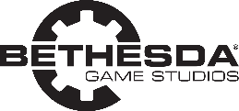

NBA 2K19

5

€49.99

BUY

4

Just Cause 4

€59.99

BUY

3

The Witcher 3: Wild Hunt

€29.99

BUY

2

Grand Theft Auto V

€29.99

BUY

The Elder Scrolls V: Skyrim

€14.99

BUY

1

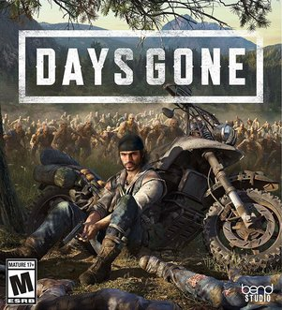

Days Gone

€59.99

PREORDER

April 26, 2019

**New Releases**

**Upcoming Games**

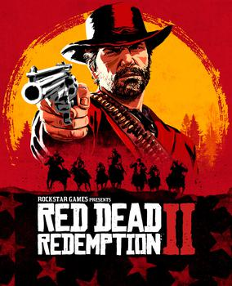

Red Dead Redemption 2

€59.99

BUY



Battlefield V

€59.99

BUY



Forza Horizon 4

€59.99

**BUY**

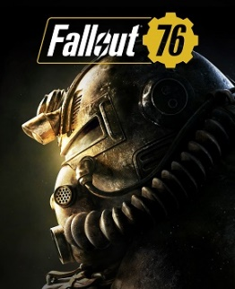

Fallout 76

€59.99

BUY

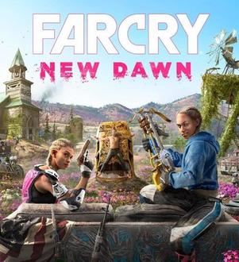

Far Cry New Dawn

€59.99

PREORDER

February 15, 2019

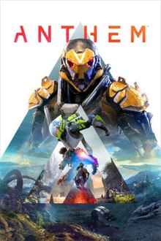

Anthem

€59.99

PREORDER

February 22, 2019

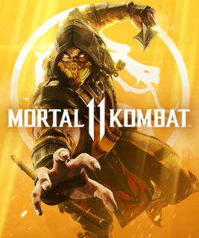

Mortal Kombat 11

€59.99

PREORDER

April 23, 2019

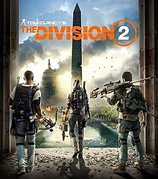

Tom Clancy’s The Division 2

€59.99

PREORDER

March 15, 2019

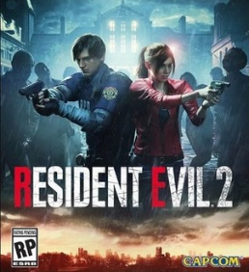

Resident Evil 2

€59.99

BUY

**Best Sellers**

**ACCOUNT**

**GAMES**

Search…

CART